* **Due** May 29 by 11:59pm

**Exercises - Graphs (Part Two)**

Answer the following questions by implementing the code samples and/or answering the questions in a word document. Upload all project files and word documents zipped to the exercise dropbox.

1. Draw a complete graph with V = 5 vertices.

2. What is the in-degree and out-degree of each of the vertices in the following graph?

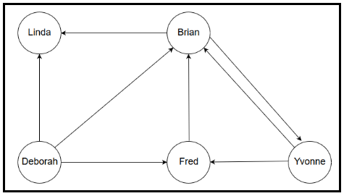

3. Name two types of problems are suitable to be modeled with directed graphs. Name two types of problems that are suitable to be modeled with undirected graphs.

5a. Find the shortest path from A to all other vertices for the following graph, using Dijkstra's algorithm. Show each of the steps during the algorithm.

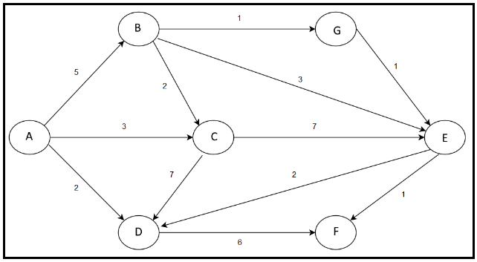

5b. Find the shortest unweighted path from B to all other vertices for the same graph.

6. Find a minimum spanning tree for the graph below using Prim's Algorithm.

